**CASE STUDY: KANBAN**

Kanban is a workflow management method for defining, managing and improving services that deliver knowledge work. It aims to help you visualize your work, maximize efficiency, and improve continuously.

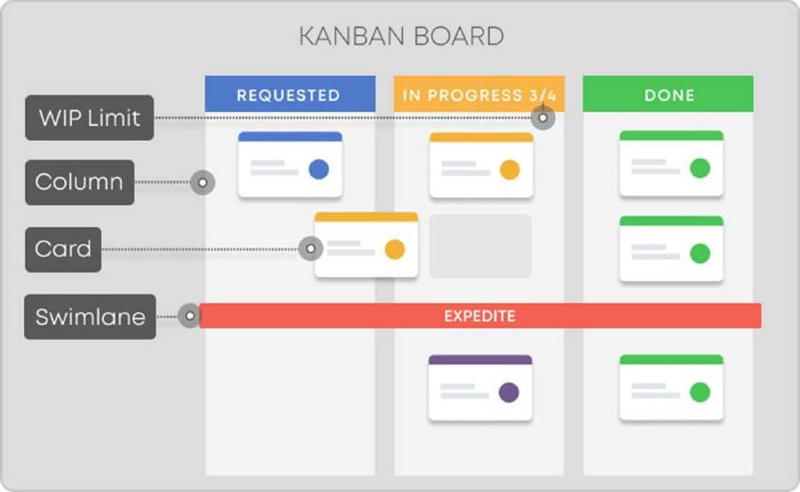

**What Is Kanban?**

The Japanese word "kanban", meaning "visual board" or a "sign", has been used in the sense of a process definition since the 1 950s. It was first developed and applied by Toyota as a scheduling system for just-in-time manufacturing. On the other hand, the capitalized term "Kanban" is known and associated with the emergence of the "Kanban Method," which was first defined in 2007.

**The Genesis of Kanban:**

Initially, it arose as a scheduling system for lean manufacturing, originating from the Toyota Production System (TPS). In the late 1940s, Toyota introduced "just in time" manufacturing to its production. The approach represents a pull system. This means that production is based on customer demand rather than the standard push practice to produce goods and push them to the market.

Their unique production system laid the foundation of Lean manufacturing or simply Lean. Its core purpose is minimizing waste activities without sacrificing productivity. The main goal is to create more value for the customer without generating more costs.

**The Kanban Method:**

At the beginning of the 21st Century, key players in the software industry quickly realized how Kanban could positively change the way products and services were delivered.

With an increased focus on efficiency and by harnessing advances in computing technology, Kanban left the automotive industrys realm and was successfully applied to other complex commercial sectors such as IT, software development, R & D and others.



Indeed, what we now recognize as the Kanban Method emerged at the beginning of 2007. It is a result of years of testing, experience, and joint efforts of leading figures in the Lean and Agile community such as David Aderson, Dan Vacanti, Darren Davis, Corey Ladas, Dominica DeGrandis, Rick Garber, and others.



You can start building your Kanban system by setting up the most straightforward Kanban board with three basic columns — "Requested", "In Progress" and "Done". When constructed, managed, and functioning correctly, it serves as a real-time information repository, highlighting bottlenecks within the system and anything else that might interrupt smooth working practices.

**Kanban Principles:**

Before exploring the Kanban values in more detail, we'd like to establish that the method in the shape and form we embrace and use today emerged due to many people's collaborative efforts. The expanding Kanban community should acknowledge these ideas and contributions as such.



David J. Anderson (a pioneer in the field of Lean/ Kanban for knowledge work and one of the founding fathers of the method) has formulated the Kanban method as an approach to incremental, evolutionary process and systems change for knowledge work organizations. It is focused on getting things done, and its fundamentals can be broken down into two types of principles and six practices.

# **Change Management Principles**

Blending with the already established processes in a non-disruptive way, pursuing evolutionary changes and continuous improvement. Let's take a closer look at the Kanban change management principles.



Principle I: Start With What You Do Now

Kanban offers the flexibility to use the method on top of existing workflows, systems, and processes without disrupting what is already in place. The method recognizes that existing processes, roles, responsibilities, and titles have value and are, generally, worth preserving. Naturally, it will highlight issues that need to be addressed and help assess and plan changes so their implementation is as non-disruptive as possible.

Principle 2: Agree to Pursue Incremental, Evolutionary Change

The Kanban method is designed to meet minimal resistance. It encourages continuous small incremental and evolutionary changes to the current process by implementing collaboration and feedback forms. In general, sweeping changes are discouraged because they usually encounter resistance due to fear or uncertainty.

## Principle 3: Encourage Acts of Leadership at All Levels

Leadership at all levels derives from people's everyday insights and acts to improve their way of working. As insignificant as you may think, each shared observation fosters a continuous improvement mindset (Kaizen) to reach optimal performance on a team/department/company level. This can't be a management-level activity.



# **Service Delivery Principles**

Kanban aims at developing a service-oriented approach. It requires that you profoundly understand your customer's needs, create a network of services where people self-organize around the work, and ensure that your system continuously evolves.

## Principle 1: Focus on Customer's Needs and Expectations

Delivering value to the customer should be at the center of each organization. Understanding the needs and expectations of your customers brings attention to the quality of the provided services and the value it creates.

Principle 2: Manage the Work

Managing the work in your network of services ensures that you empower people's abilities to self-organize around the work. This enables you to focus on the desired outcomes without the "noise" created by micro-managing the people delivering the services.



## Principle 3: Regularly Review the Network of Services

Once developed, a service-oriented approach requires continuous evaluation to foster a customer service culture. Through the use of regular reviews of the network of services and assessment of the applied work policies, Kanban encourages the improvement of the delivered results.

## **Kanban Practices**

When aiming to implement the Kanban method, every organization must be careful with the practical steps. Six core practices need to be present for a successful implementation. While mastering these is vital, it's an evolving process - close to 40% of all organizations admit that the way they use the Kanban practices still matures. Let's take a closer look.



## 1. Visualize the Workflow

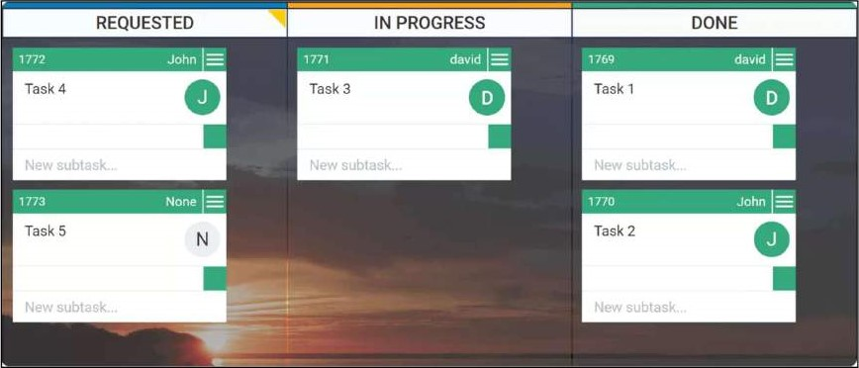

To visualize your process with a Kanban system, you will need a board with cards and columns. Each column on the board represents a step in your workflow. Each Kanban card represents a work item. The Kanban board itself represents the actual state of your workflow with all its risks and specifications.

The first and most important thing for you is understanding what it takes to get an item from a request to a deliverable product. Recognizing how work flows through your system will set you on the path to continuous improvement by making well-observed and necessary changes.

When you start working on item X, you pull it from the "To Do" column, and when it is completed, you move it to "Done". This way, you can easily track progress and spot bottlenecks. Naturally, your Kanban board might have a different outlook as it depends on your specific needs and processes.

## 2. Limit Work in Progress (WIP)

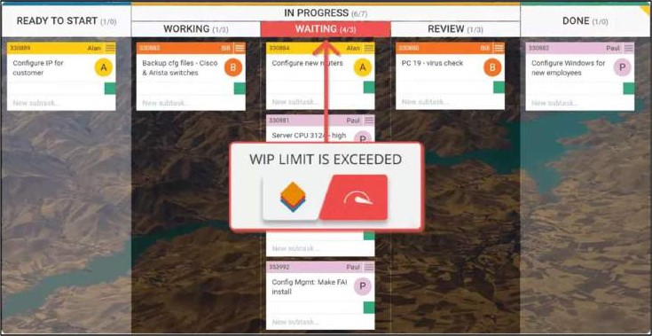

One of Kanban's primary functions is to ensure a manageable number of active items are in progress at any one time. If there are no work-in-progress limits, you are not doing Kanban. Switching a team's focus halfway through will generally harm the process, and multitasking is a sure route to generating waste and inefficiency.

Limiting WIP means implementing a pull system on parts or the complete workflow. Setting maximum items per stage ensures that a card is only "pulled" into the next step when there is available capacity. Such constraints will quickly illuminate problem areas in your flow so you can identify and resolve them.

3. Manage Flow

Managing the flow is about managing the work but not the people. By flow, we mean the movement of work items through the production process at a predictable and sustainable pace.

One of the main goals when implementing a Kanban system is to create a smooth, healthy flow. Instead of micro-managing people and trying to keep them busy all the time, you should focus on managing the work processes and understanding how to get that work faster through the system. This would mean that your Kanban system IS creating value more quickly.

## 4. Make Process Policies Explicit

You can't improve something you don't understand. This is why your process should be clearly defined, published, and socialized. People would not associate and participate in something they do not believe would be useful.

When everyone is familiar with the common goal, they would be able to work and make decisions regarding a positive impact. Sparse, visible, well-defined, and subject to change (if/when needed), work policies have the power to boost people's self-organization.

## 5. Feedback Loops

For teams and companies that want to be more agile, implementing feedback loops is a mandatory step. They ensure that organizations are adequately responding to potential changes and enable knowledge transfer between stakeholders.

Kanban suggests the use of cadences (feedback loops) at a team level as well as service-oriented cadences.

An example of a team-level cadence is the daily Team Kanban Meeting for tracking the status and the flow of work. It helps to identify available capacity and potential for increasing the delivery pace. It takes place in front of the Kanban board, and every member tells the others what they did the previous day and what they will be doing today.

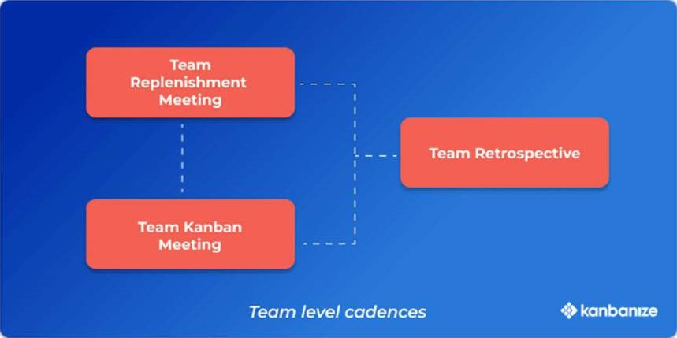

Service-oriented cadences in Kanban, such as operations, service delivery, and risk meetings, aim to synchronize and improve your delivery of service. The output of these reviews, such as understanding what is blocking effective service delivery, should serve as a decision-making input for the continuous improvement of your network of services.



While focused and regular meetings with fewer attendees have proven to be a good practice, the ideal duration of specific Kanban cadences depends on your context, the team size, and topics.

6. Improve Collaboratively (using models & the scientific method)

The way to achieve continuous improvement and sustainable change within an organization is through collaboratively implementing changes based on scientifically proven methods, feedback, and metrics.

Cultivating an organizational culture where every hypothesis is proven to have positive or negative results is crucial for developing a mindset focused on improvement through evolutionary change.

**How to Use Kanban for Project Management?**

To use Kanban for project management, all teams involved should use Kanban boards to manage their work. Therefore, all these team boards have to be considered a network of services through which the project work flows. This is the foundation of each value delivery system.

The practices of Kanban provide a holistic approach to project management and guidance on how to achieve a predictable workflow and improve collaboration while working on different projects.

1. Visualize processes and workflows. Visualize all work items and all project, program, and portfolio workflows through a set of inter-connected kanban boards. This will provide a real-time overview of the status of all projects, blockages, risks, and related tasks. Furthermore, visualizing the processes and the decision-making policies will facilitate the correct execution of the work and will allow different teams to identify and define improvements in the process. Also, all the teams involved in the project will be able to monitor their progress in real-time and decide what to focus on now and what to do next.



2. Use flow- and outcome-oriented metrics. Use relevant metrics to manage workflow and outcomes such as system lead time, cycle time, blocked time, flow efficiency, etc. These metrics will help you see how fast your team can deliver work to the market, what the productivity levels are, where wasteful activities appear, what the demand is, and more.

3. Establish feedback loops. Conduct a cadence of meetings and reviews that keep the organization aligned and focused on meeting customer needs and business objectives. These regular meetings ensure the flow of information and guidelines necessary to execute projects successfully and meet both customer expectations and business objectives. They also facilitate the synchronization and alignment of teams and projects in the organization.



Kanban will help you accomplish many of your project management activities faster, better, and with less bureaucracy. Using real data of your system's capacity allows you to create predictive models and plan with confidence. The analysis of flow-related data, the impact of blockers, dependencies, and reworks, provides a deeper understanding of the sources of delay and facilitates the definition of the right actions to address the risk of delays or low quality.

And last but not least, Kanban project management boards continuously communicate work item status, team workload, workflow blockers, and risks at any level. This constant stream of information helps you keep all teams aligned with company goals.

**Top Benefits of Kanban**

According to the 1st State of Kanban report, the leading reasons for adopting the Kanban method are the need for enhanced visibility of work and continuous improvement. Let's reveal some more of the benefits of using Kanban today.

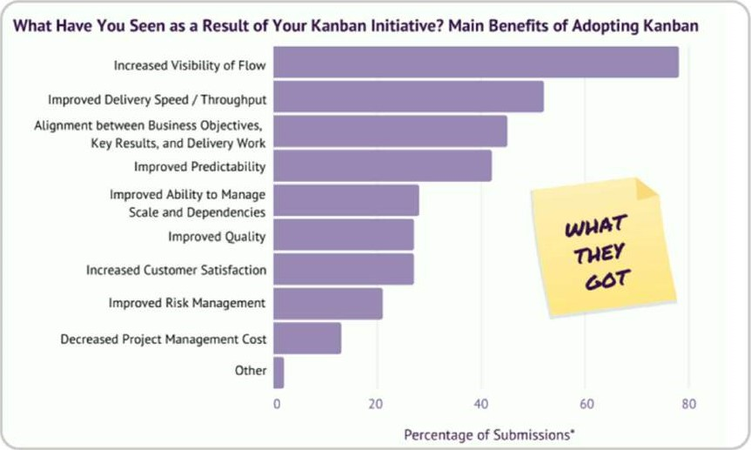

1. Increased Visibility of the Flow

The basic idea of Kanban is visualizing every piece of work. This way, the Kanban board turns into a central informational hub, and everyone is on the same page. All tasks are visible, and they never get lost, which brings transparency to the whole work process. Every team member can have a quick update on the status of every project or task.



1. Improved Delivery Speed

Kanban offers multiple ways for project managers to closely monitor and make informed analyses of the distribution of work. With a clear view over the work items completed for a certain period of time, the stages where tasks spend the longest, bottlenecks are easy to identify. Teams are enabled to tackle these challenges to improve their workflow and, ultimately, their delivery rate.



## 3. Alignment between Business Goals and Execution

Promoting transparency, encouraging feedback, and regular review meetings, Kanban practices enable aligning the company's strategic goals with teams' day-to-day work. This alignment between the business direction and execution enhances the agility of an organization. It allows teams to adapt to changing priorities and reorganizations due to change in the market or customer's requirements.

1. Improved Predictability

Once you create a Kanban board and start accumulating work items on it, you'll be able to understand your process in depth with flow metrics. Analyzing the time tasks spend in your workflow (cycle time) will enable you to improve your predictions on how much work you can deliver in the future. Understanding your delivery rate consistency (throughput) will make your forecasts more accurate and your decisions based on historical data.

1. Improved Ability to Manage Scale and Dependencies

The intrinsic Kanban practice to visualization is also applied when it comes to mapping and managing dependencies. Starting with what you do now means visualizing the present dependencies and managing the flow between them. Managing dependencies provides both insights on the present state of a workflow and ideas for improvement. On the other hand, it also enables full transparency for strategic management over the workflow and the existing links between teams.

1. Increased Customer Satisfaction

The origin of the Kanban method - the pull system it is based on implies that work is done when there's a demand. In other words, Kanban navigates you to reduce waste by working solely on tasks that are needed at present. Furthermore, by applying visualization techniques and introducing work-in-progress limits to the process, you will ensure that the end result is fine-tuned to your customer's expectations.

**Modern-Day Kanban**

With the development of technology, Kanban has also been continuously improving. With digital Kanban board solutions, overcome the problems arising in remote teams.

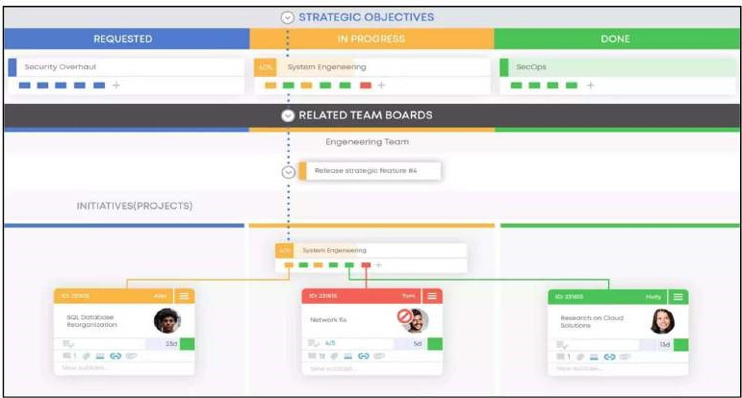

I. Easy access for remote team members

Nowadays, teams are often distributed all over the world. They cannot work on a physical whiteboard and thus need a digital one they could access from anywhere to be more agile. Kanban boards in the cloud are the most effective way to get everyone on the same track. They provide access to all of the information from any device at any time and show actions live.

## 2. Flow analytics

Moreover, Kanban software allows for a sophisticated analytical process to help you track performance in detail, discover bottlenecks, and implement the necessary changes.



1. Integrations with other tools

Digital boards are also easy to integrate with other systems. They can give a valuable perspective of the whole process, save time, and increase efficiency.



1. Workflow automation

The online Kanban solution allows you to automate some parts of your processes and save valuable time. With custom automatons, any typical workflow can be made more efficient.

**What Are the Main Kanban Terms You Should Know?**



At its core, Kanban is a work method that helps you optimize the flow of value through your value streams from ideation to customer. Although it looks like an easy way to improve your work processes, Kanban is more than visualizing your work. You need to pay attention to detail and get familiar with the basic Kanban terms and artifacts if you want to benefit from applying the method.



Here is a short Kanban glossary that will help you get started.

* 1. Kanban board: A Kanban board is one of the Kanban method's key components and is where you visualize all work items. It should be divided into a minimum of 3 columns — Requested, In Progress, Done, representing different process stages.
  2. Kanban card: Kanban cards represent the different work items moving through a Kanban board. They contain important details about the tasks such as description, deadline, size, assignees, etc.
  3. Columns: They split the Kanban board vertically, and each of them represents a different stage of the workflow. Each Kanban board has 3 default columns: Requested, In Progress, Done. Depending on the complexity of a work process, these three stages can be divided into many smaller sub-columns.
  4. Swimlanes: Horizontal lanes that split a Kanban board into sections. Teams use them to visually separate different work types on the same board and organize homogenous tasks together.
  5. Cycle Time: Cycle time begins at the moment when a new task enters the "in progress" stage of your workflow, and somebody is actually working on it.



6 Lead Time: Lead time starts at the moment a new task is being requested (it doesn't matter if somebody is actually working on it) and ends with its final departure from the system.

1. Throughput: The number of work items passing through (completed) a system or process over a certain period. The throughput is a key indicator showing how productive your team is over time.
2. Work in Progress (WIP): This is the amount of work you are currently working on and it is not finished yet.
3. WIP limits: Limiting work in progress means limiting the number of tasks your team can work on simultaneously to avoid overburdening and context switching.

**Kanban in a Nutshell**

A Kanban system is more than sticky notes on the wall. The easiest way to understand Kanban is to embrace its philosophy and apply it to your daily work. If you read, understand, and resonate with its core principles, the practical transition would seem logical and even inevitable.